MEMT201

CARDENAS

HW #13

Problem 1

A continuous and aligned fiber-reinforced composite is to be produced consisting of 30 vol% aramind fibers and 70 vol% of a polycarbonate matrix; mechanical characteristics of these two materials are as follows;

Material Modulus of Elasticity, (GPa (psi)) Tensile Strength (MPa (psi))
_______________________________________________________________________
Aramid Fiber 131 (19 x 10⁶) 3600 (520,000)

Polycarbonate 2.4 (3.5 x 10⁵) 65 (9425)
_______________________________________________________________________

Also the stress on the polycarbonate matrix when the aramid fibers fail is 45 MPa (6500 psi)

For this composite, compute;

(a) the longitudinal tensile strength

From the PowerPoint on composites:
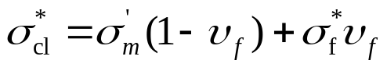
σ_{cl}* = 45 MPa * (1 – 30%) + 3600 MPa * 30% = 45 MPa * 0.7 + 3600 MPa * 0.3 = 1111.5 MPa

(b) the longitudinal modulus of elasticity

Likewise:
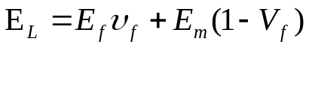
E_{L} = 2.4 GPa * 70% + 131 GPa * 30% = 2.4 GPa * 0.7 + 131 GPa * 0.3 = 40.98 GPa
Problem 2

For a continuous and oriented fiber-reinforced composite, the moduli of elasticity in the longitudinal and transverse directions are 19.7 and 3.66 GPa (2.8 x10⁶ and 5.3 x 10⁵ psi), respectively. If the volume fraction of fibers is 0.25, determine the moduli of elasticity of fiber and matrix phases.

From the formula above:
19.7 GPa = E_{f} * 0.25 + E_{m}(1- 0.25)
= 0.25E_{f} + 0.75E_{m}
E_{m} = 26.27 GPa – 0.3333E_{f}

Using the formula for transverse modulus:
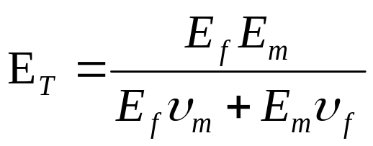
3.66 GPa = E_{f}(26.27 GPa – 0.3333Ef) / (E_{f}(1-0.25) + (26.27 Gpa – 0.3333E_{f}))

E_{f} = 70.12 GPa

E_{m} = 26.27 GPa – 0.3333(70.12 GPa) = 2.897 GPa

